Business / Economy

The US economy grew by 5.2% in the third quarter, even faster than previously estimated
By Bryan Mena, CNN
3 minute read
Updated 11:15 AM EST, Wed November 29, 2023
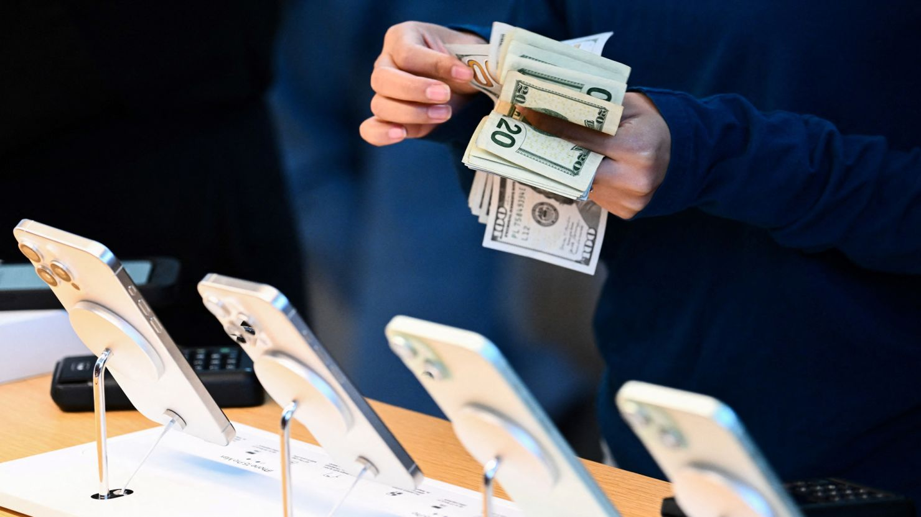
After a robust third quarter, the US economy is widely expected to grow at a much slower rate in final months of the year as pandemic savings dwindle and interest rates remain at a 22-year high.
Washington, DCCNN —
US economic growth was even stronger in the third quarter than previously estimated, underscoring the economy’s remarkable resilience in the face of elevated inflation and high borrowing costs earlier this year.
Gross domestic product, the broadest measure of economic output, rose at an annualized rate of 5.2% from July through September, according to the Commerce Department’s second estimate, released Wednesday morning. GDP is adjusted for inflation and seasonal swings.
Wednesday’s latest reading reflects an even faster pace of growth than the blistering 4.9% rate the department initially estimated. It factors in greater business investment, government outlays, residential investment and inventory growth.
Nonresidential fixed investment, or business spending, was revised up to a growth rate of 1.3% in the third quarter from a decline of 0.1%. Residential investment, which generally reflects conditions in the housing market, was revised much higher, to 6.2% from 3.9%.
Meanwhile, consumer spending, America’s main economic engine, was revised slightly lower, to 3.6%, down from the 4% in the initial estimate. That’s still a solid pace of growth.

Economic slowdown ahead
After a robust third quarter, the US economy is widely expected to grow at a much slower rate in the final months of the year as pandemic savings dwindle and interest rates remain at a 22-year high.
Consumer spending seems solid for now: Black Friday and Cyber Monday sales this year were record setting, according to Adobe Analytics.

The holiday spending spree is fueled by ‘Buy Now, Pay Later’ shoppers
Fourth-quarter spending likely won’t be as piping hot, however. Retail sales fell in October for the first time in seven months, declining 0.1% that month from September.
Business surveys from the Institute for Supply Management also showed that economic activity in both the services and manufacturing sectors slowed last month.
And the job market, which begets the temperature of spending, has also cooled recently. Employers added 150,000 jobs last month, below expectations and down from September’s gain of 297,000 jobs.
Real-time estimates of fourth-quarter GDP are also reflecting a slower pace of growth. The Atlanta Fed is currently projecting fourth-quarter GDP to come in at a 2.1% annualized rate.

Enter your email to receive CNN's nightcap newsletter.
close dialog



We read all day so you don’t have to.
Get our nightly newsletter for all the top business stories you need to know.

By subscribing you agree to our
privacy policy.

“As we warned last month, evidence of economic strength over the summer could mislead some to assume the economy is on a strong trajectory — it is not,” said Gregory Daco, chief economist at EY-Parthenon, in a note Wednesday.
“We continue to believe cooler days are on the horizon with cost fatigue — the perception that the cost of everything is higher than pre-pandemic — rising debt servicing burdens and slowing job growth dampening consumers’ and businesses’ ability and desire to spend and invest,” he said.

The Fed will likely pause again
The Federal Reserve seems likely to keep interest rates on hold for the third consecutive meeting next month, according to recent hints from central bank officials. Investors are also overwhelmingly betting on a third pause.
Fed officials pay close attention to various facets of the US economy when deliberating monetary policy, including growth.
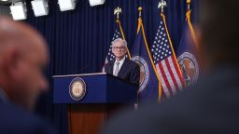
The Fed is probably done hiking rates. Cuts are still far off
“All in all, it seems like output growth is moderating as I had hoped it would, supporting continued progress on inflation,” Fed Governor Christopher Waller said Tuesday at an event hosted by the American Enterprise Institute.
Waller, a top Fed official who has usually backed an aggressive stance on fighting inflation, said that he is “increasingly confident that policy is currently well positioned to slow the economy and get inflation back to 2%,” the Fed’s inflation target.
While the Fed is likely to keep interest rates at a 22-year high during its December 12-13 policy meeting, some officials still believe there’s more room for rate increases.
Fed Governor Michelle Bowman, one of the central bank’s most hawkish officials, said Tuesday at an event in Salt Lake City that she expects “we will need to increase the federal funds rate further to keep policy sufficiently restrictive to bring inflation down to our 2% target in a timely way,” citing the risk that inflation’s descent could stall.

